**CS 596 Homework Assignment 3**

**Machine Learning**

**Problem 1:**

**Step 1: Split the generated Data into training and testing subsets**

Here, the random indices for the training data is first generated. The random indices are stored and then the respective elements from the Data Values (X) and the True Values (y) are stored in trainX and trainY variables.

The selected indices are then removed from the entire index list and then those elements are stored in testX and testY values.

Also, the 0.8 used during the calculation of the numElems is used to determine that 80% of the data is used for training the model which can be modified accordingly.

maxIndex = len(X)

ln = maxIndex

numElems = int(0.8*ln) # number of elements required

indices = sample(range(ln),numElems)

trainX = X[indices] # training samples

trainY = y[indices] # labels of training samples nTrain X 1

txArr = np.delete(range(ln), indices) # testing samples

testX = X[txArr]

tyArr = np.delete(range(ln), indices) # labels of testing samples nTest X 1

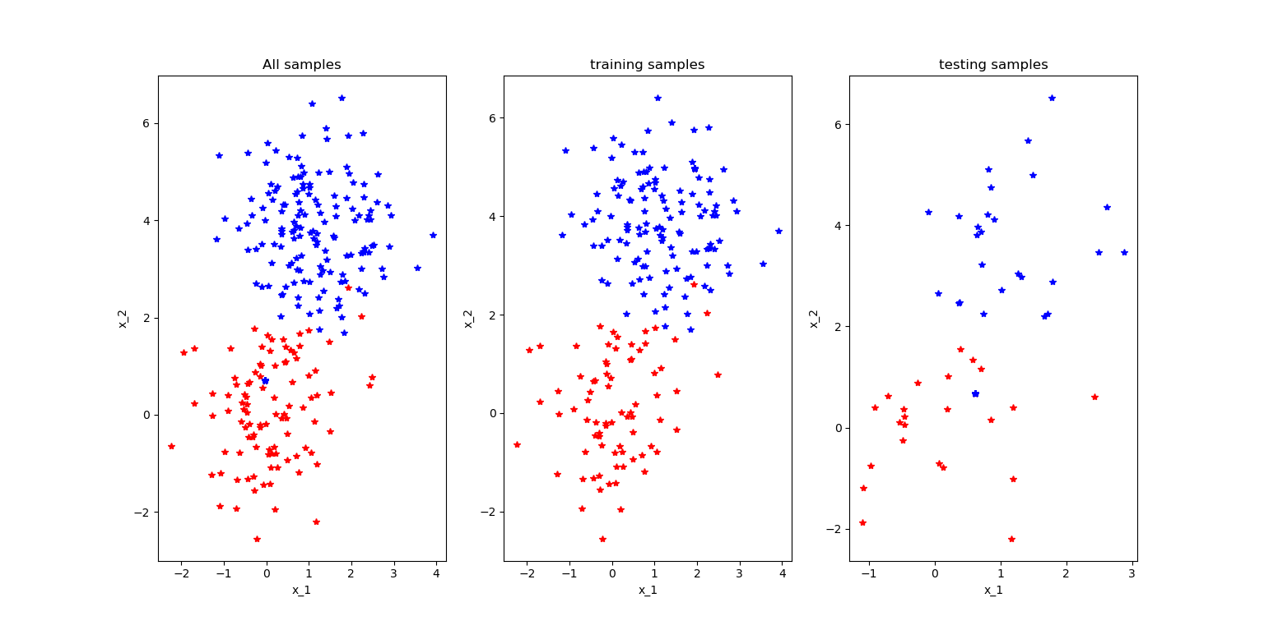

testY = y[tyArr]

**Step 2: Training a logistic regression model using the training data**

There are 2 ways by which the logistic regression model is trained. One of them being by using the sklearn library and the second method being by self-defined model.

Sklearn Model:

Here, the functions from the sklearn are used to train the model.

The fit function is used to train the model and the score function is used to test the accuracy of the trained model. The model is then plotted on the graph using the training set.

from sklearn.linear_model import LogisticRegression

# USING SAMPLE METHOD

clf = LogisticRegression()

clf.fit(trainX,trainY)

print('score Scikit learn: ', clf.score(testX,testY))

# visualize data using functions in the library pylab

pos = np.where(y == 1)

neg = np.where(y == 0)

# print("POS: ", pos[0])

# print("NEG: ", neg[0])

plt.scatter(X[pos, 0], X[pos, 1], marker='o', c='b')

plt.scatter(X[neg, 0], X[neg, 1], marker='x', c='r')

plt.xlabel('Feature 1: score 1')

plt.ylabel('Feature 2: score 2')

plt.legend(['Label: Admitted', 'Label: Not Admitted'])

plt.show()

Self-Defined Model:

You use the alpha (learning rate), theta and maximum number of iterations, to calculate the gradient descent. The cost function is then calculated using the following formula:

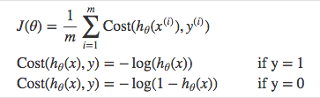

theta = [0,0] #initial model parameters

alpha = 0.1 # learning rates

max_iteration = 1000 # maximal iterations

m = len(y) # number of samples

for x in range(max_iteration):

# call the functions for gradient descent method

new_theta = Gradient_Descent(X,y,theta,m,alpha)

theta = new_theta

if x % 200 == 0:

# calculate the cost function with the present theta

Cost_Function(X,y,theta,m)

print('theta ', theta)

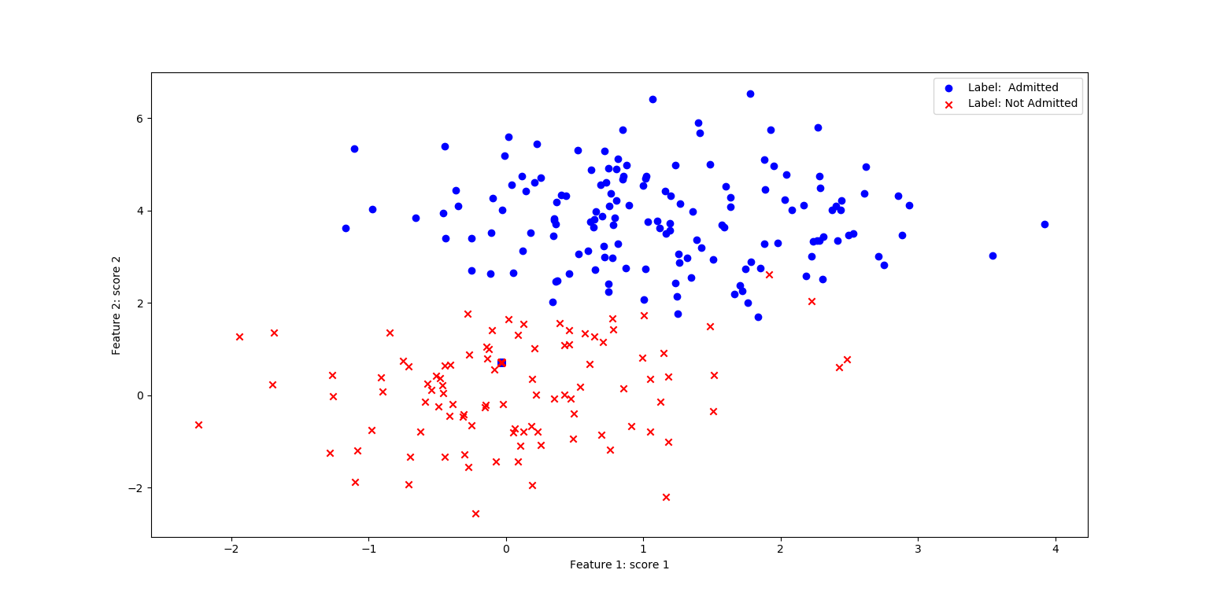

print('cost is ', Cost_Function(X,y,theta,m))

**Step 3: Applying the learned model to get binary classes of testing samples**

There are a few steps involved to get binary classes of the testing samples.

First the prediction function is applied to each of the testing data points, the prediction function calculates the sigmoid function which is summation of all the points with i as each point

1/(1+e- x[i] * tetha[i] )

If the prediction and the actual test value is same, the score is incremented and the total score is divided by the number of data values to get the accuracy or the score of your model.

The difference between the actual test value and the prediction. This is then squared and this is added to get the total summation of all the elements which could be used later to determine Mean Squared Error.

score = 0

summation = 0

pred = np.empty(shape=[0, 1])

# accuracy for sklearn

scikit_score = clf.score(testX,testY)

# accuracy for own model

length = len(testX)

for i in range(length):

prediction = round(Prediction(testX[i],theta))

answer = testY[i]

difference = testY[i] - prediction

squared_difference = difference**2

summation = summation + squared_difference

pred = np.append(pred, [[prediction]], axis=0)

if prediction == answer:

score += 1

# print("pred1 ", pred)

# print("test1 ", testY)

my_score = float(score) / float(length)

yHat = pred

**Step 4: Comparing the** **predictions with the ground-truth labels and calculate average errors and standard deviation**

After we have all the predictions, we can compare them by subtracting the predictions from the respective training set Ground Truth (Y) values.

The average error is then determined by calculating the mean and standard deviation of the difference.

Moreover, I also calculated the difference through the Mean Squared Error (MSE) method.

This was calculated by taking the taking summation from the above step and dividing by the len of predictions.

**Problem 2:**

A confusion matrix is a matrix that can be used to measure the performance of a machine learning model.

Each row of the confusion matrix represents the instances of an actual class and each column represents the instances of a predicted class.

The diagonal from top-left to bottom right is supposed to be the true positive values.

These values are the values that match in the prediction and true value.

|  |  |  |  |  |  |  |  |  |  |  |  |  |  |  |  |  |  |  |  |  |
| --- | --- | --- | --- | --- | --- | --- | --- | --- | --- | --- | --- | --- | --- | --- | --- | --- | --- | --- | --- | --- |
| Image ID | 1 | 2 | 3 | 4 | 5 | 6 | 7 | 8 | 9 | 10 | 11 | 12 | 13 | 14 | 15 | 16 | 17 | 18 | 19 | 20 |
| True class | C | C | C | C | C | D | D | D | D | D | D | D | D | M | M | M | M | M | M | M |
| Predicted class | D | C | D | D | M | D | D | C | C | M | M | D | C | C | C | M | M | D | D | M |

|  |  |  |  |
| --- | --- | --- | --- |
|  | CAT | DOG | MONKEY |
| CAT | 1 | 3 | 2 |
| Dog | 3 | 3 | 2 |
| Monkey | 1 | 2 | 3 |

Total Label

**The Accuracy** of the matrix could be determined by adding the top left to bottom right diagonal and then dividing it by the total number of elements.

Therefore, the accuracy is $\frac{7}{13+7}= \frac{7}{20}=35\%$

**Precision:** It is the proportion of cases correctly identified as belonging to class *c* among all cases of which the classifier claims that they belong to class *c*.

Precision of Cat: $\frac{true positive of cat}{Total Predicted}= \frac{1}{6}=0.167$

Precision of Dog: $\frac{true positive of Dog}{Total Predicted}= \frac{3}{8}=0.375$

Precision of Monkey: $\frac{true positive of Monkey}{Total Predicted}= \frac{3}{6}=0.5$

**Recall Value:** It is the proportion of cases correctly identified as belonging to class *c* among all cases that truly belong to class *c*.

Recall of Cat: $\frac{true positive of cat}{Total labelled}= \frac{1}{5}=0.2$

Recall of Dog: $\frac{true positive of Dog}{Total labelled}= \frac{3}{8}=0.375$

Recall of Monkey: $\frac{true positive of Monkey}{Total labelled}= \frac{3}{7}=0.4285$

**Problem 3:**

A confusion matrix is a matrix that can be used to measure the performance of a machine learning model.

Each row of the confusion matrix represents the instances of an actual class and each column represents the instances of a predicted class.

The first confusion matrix is supposed to be the CM of our own prediction and the second confusion matrix is supposed to be the CM of the pre-defined method.

The func_calConfusionMatrix is stored in the util.py file in the end.

The confusion matrix is then created and then the accuracy, prediction and recall is determined.

The following formulas are used for precision and recall respectively,

**Recall:** Recall gives us an idea about when it’s actually yes, how often does it predict yes.  
Recall=True Positive / (True Positive + False Negative)

**Precision:** Precision tells us about when it predicts yes, how often is it correct.  
Precision = True Positive / (True Positive + False Positive)

Confusion Matrix :

|  |  |  |
| --- | --- | --- |
|  | **Class 1 Predicted** | **Class 2 Predicted** |
| **Class 1 Actual** | True Positive | False Negative |
| **Class 2 Actual** | False Positive | True Negative |

# Own Prediction

conf, acc, prec, recall = func_calConfusionMatrix(yHat, testY)

print("CM \n", conf)

print("Accuracy:", acc)

print("precision:", prec)

print("Recall:", recall)

# Sample Prediction

conf, acc, prec, recall = func_calConfusionMatrix(pred2, testY)

print("CM \n", conf)

print("Accuracy:", acc)

print("precision:", prec)

print("Recall:", recall)

def func_calConfusionMatrix(predY, trueY):

classes = np.unique(np.concatenate((trueY,predY)))

accuracy = 0

nOfClasses = 0

nOfClasses += np.unique(trueY)

nOfClasses += np.unique(predY)

cm = np.empty((len(classes),len(classes)))

for i,k in enumerate(classes):

for j,l in enumerate(classes):

cm[i,j] = np.where((trueY==k)*(predY==l))[0].shape[0]

for i in range(len(predY)):

if predY[i] == trueY[i]:

accuracy += 1

finalAccuracy = accuracy/len(predY)

cm = np.array(cm)

truePos = np.diag(cm)

precision = np.sum(truePos / np.sum(cm, axis=0))

recall = np.sum(truePos / np.sum(cm, axis=1))

return cm, finalAccuracy, precision, recall

Average Error: 0.32 (0.466476151587624)

Mean Squared Error: [0.32]

CM

[[ 8. 16.]

[ 0. 26.]]

Accuracy: 0.68

precision: 1.619047619047619

Recall: 1.3333333333333333

CM

[[11. 13.]

[ 1. 25.]]

Accuracy: 0.72

precision: 1.5745614035087718

Recall: 1.419871794871795

[Finished in 38.126s]